Test Exercise

Pic we got for reference :

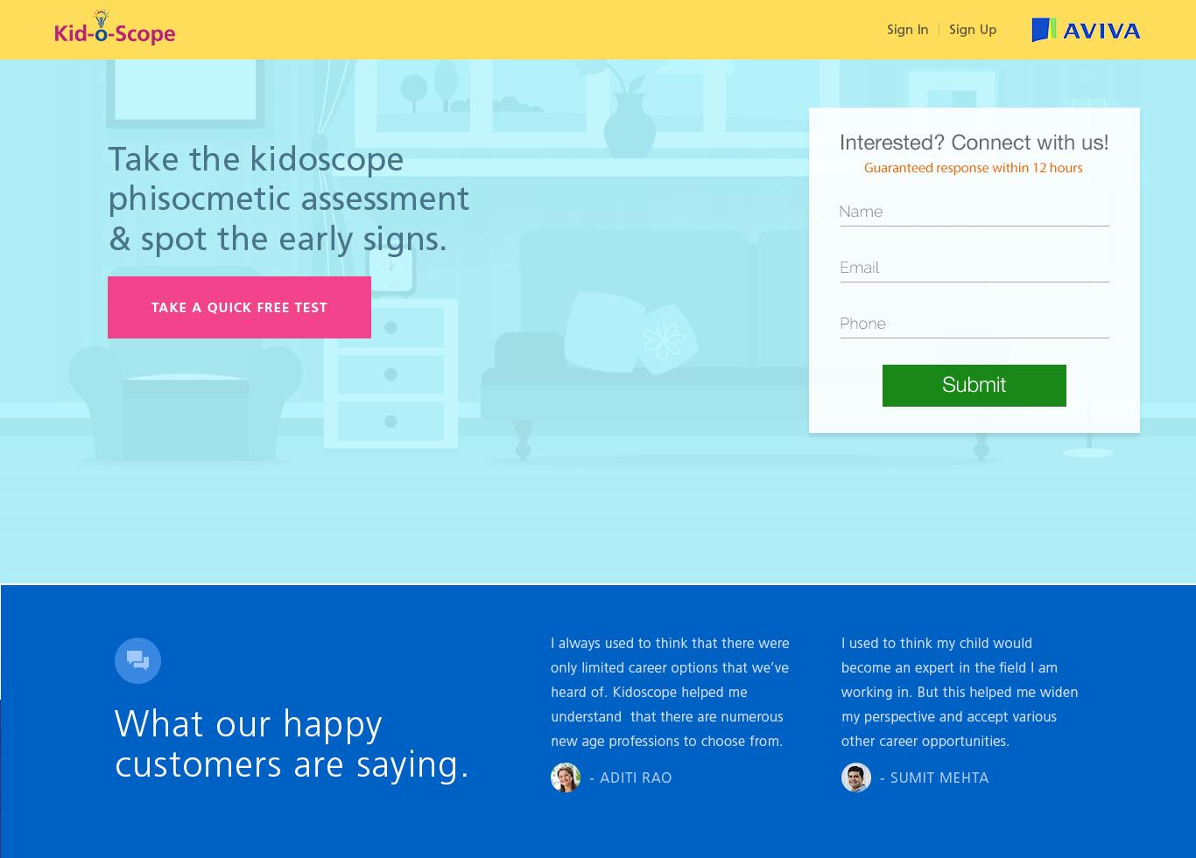

Solution : please find index.html